Individual Portfolio / Report Planning

Portfolio section | What to write | Evidence to link
Introduction | Briefly introduce the project, game topic, group role and aim.  - Phishing awareness  - Awareness to the student about online scams and help to prevent that scam  - Cyber Run  - My role is designing the game concept / story board and presentation in Canvas and PowerPoint. | 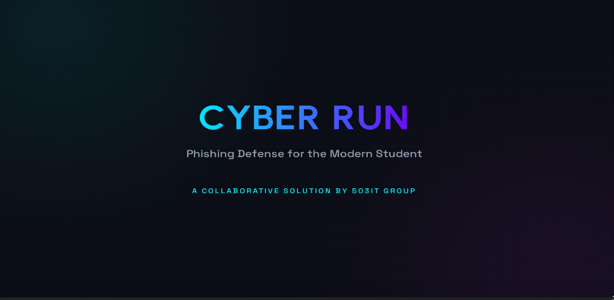
Project planning and teamwork | Explain meetings, role allocation and how the team organized work.  - Meeting held during the class weekly  - Roles are allocated to every member by the leader and member do their task according to what they are assigned.  - We discussed everything first what we going to do and help each other in research in between or have any question we talk about it directly . | 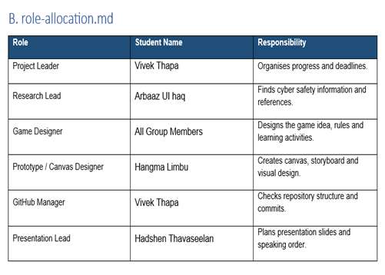
Personal contribution | Explain exactly what you personally did.  - Well from past weeks have done the design of game concept in canvas and story board for the game  - Write a report on the activity task and help with building prototype plan.  - Plan a presentation plan for the group presentation | 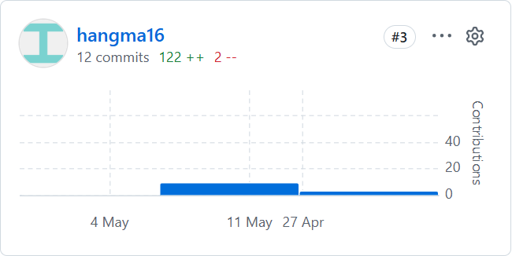  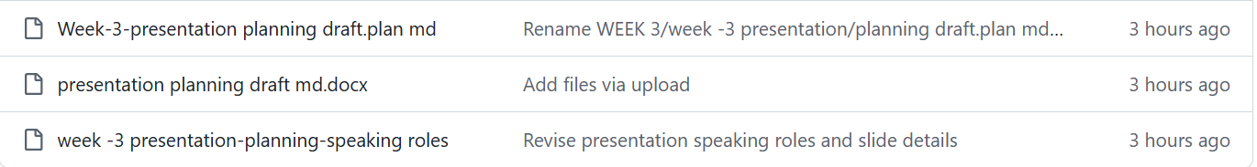
Prototype development | Explain how the game/prototype developed over time.  - Well in first week we discussed our game how it’s going to be like and how it is going to work.  - Second, we designed the game concept plan and story board and started to work in developing the game.  - During the third week we progressed on developing the game and managed to fix some bugs and improved it overtime  - We are still working on the game to improve it more and fix every bug. | 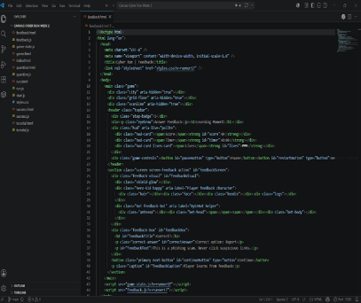  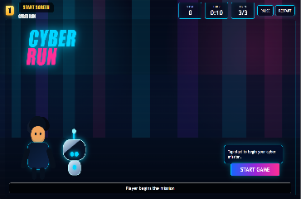  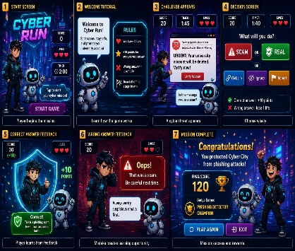  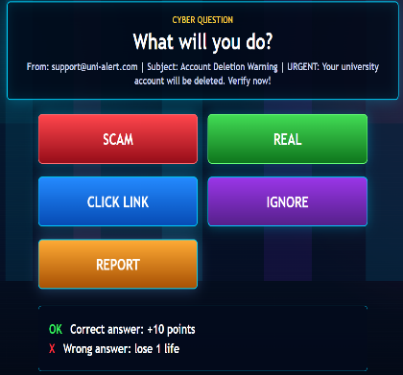
Communication and collaboration reflection | Reflect on teamwork, communication, conflict, feedback and improvement.  - We have great teamwork and communication .  - We communicated every time when there is issued and question  - We tried to make everything and organized everything as good and simple so everybody can understand our work .  - We tried to improve from the feedback we received and from our colleagues . | 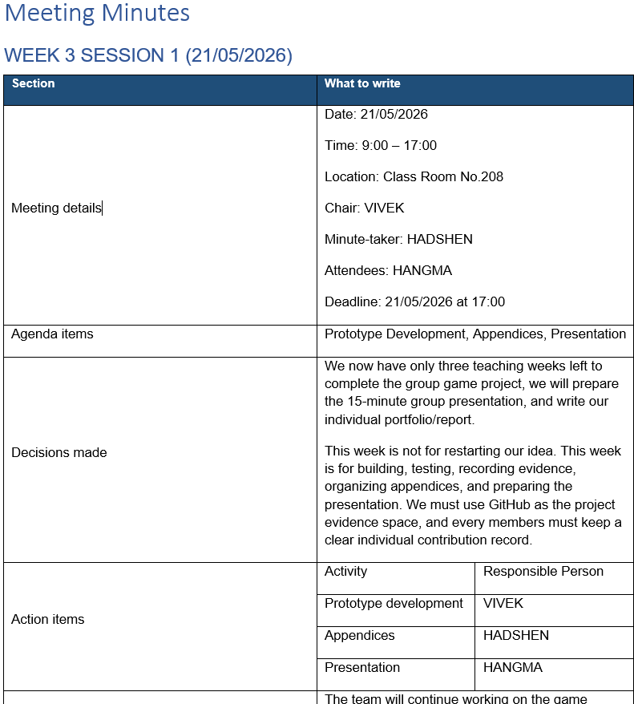
Professional development | Explain what you learned for future professional practice.  - I learned about html, CSS and java script .  - I learned about teamwork and having the importance of communication in teamwork  - I learned about how GitHub works and canvas works. | 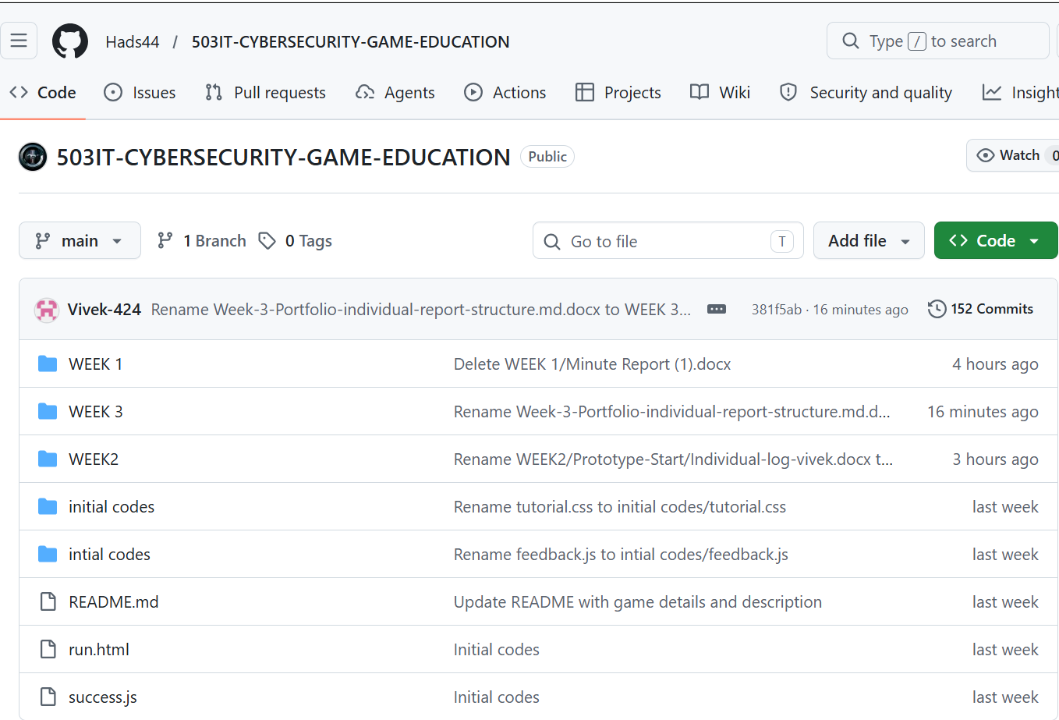
AI use statement | Declare how AI was or was not used.  - AI used  ChatGPT and canvas  Well canvas was used to make design for our game concept and ChatGPT was used to help me understand the activity task and idea of game and development of the game . | 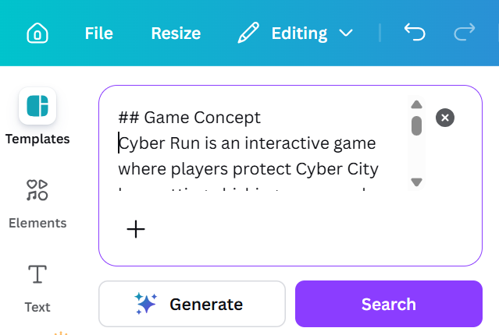
Appendices | Include supporting evidence in labelled appendix sections. | Appendix evidence map  